- Business survey data suggests that UK activity has continued to grow at a solid pace in Q3. The composite PMI is running at a similar level to H1 2024, though the patchy relationship with official output data suggests we shouldn't take these results too literally. Indeed, we think GDP growth will be slightly slower in Q3 than the above-trend pace seen in H1.
- We’re not seeing the news on inflation that would justify the Monetary Policy Committee deviating from the gradualist approach it advocated at the August meeting. One potential trigger for faster rate cuts would be a more aggressive tightening of fiscal policy, and another poor set of borrowing figures highlighted the challenges facing the Chancellor ahead of October's Budget.
A low-key week for data releases has largely confirmed what we already knew, namely that activity is growing at a solid pace, price pressures are cooling but not quickly enough to warrant back-to-back rate cuts, and the government faces some difficult fiscal policy decisions ahead of October's Budget.
August's flash S&P Global survey reported an increase in the composite PMI to 53.4, from 52.8 in July. Results have been volatile from month-to-month, but the average for Q3 to date is similar to that seen in H1 2024. The details of August's survey were encouraging, with reports of stronger domestic demand, business sentiment, and hiring.
The read-across from the PMIs to official output data has been patchy in recent years, with the survey tending to offer a sense of the direction of travel but being a poor indicator of growth rates (Chart 1). The weak relationship is partly due to what's been happening in sectors not covered by the S&P Global survey, with retail sales having been very volatile and public sector strikes hitting output in some months. But the relationships have also been weak at a sectoral level, particularly in manufacturing. Indeed, the relative strength of August's flash S&P Global manufacturing results was at odds with the much softer CBI survey. But taking a broad sweep of the data available so far for Q3, we think that the economy is continuing to grow at a solid pace, if not quite as strongly as it did earlier in the year.
Chart 1: The composite PMI suggests that activity continues to grow at a decent pace in Q3
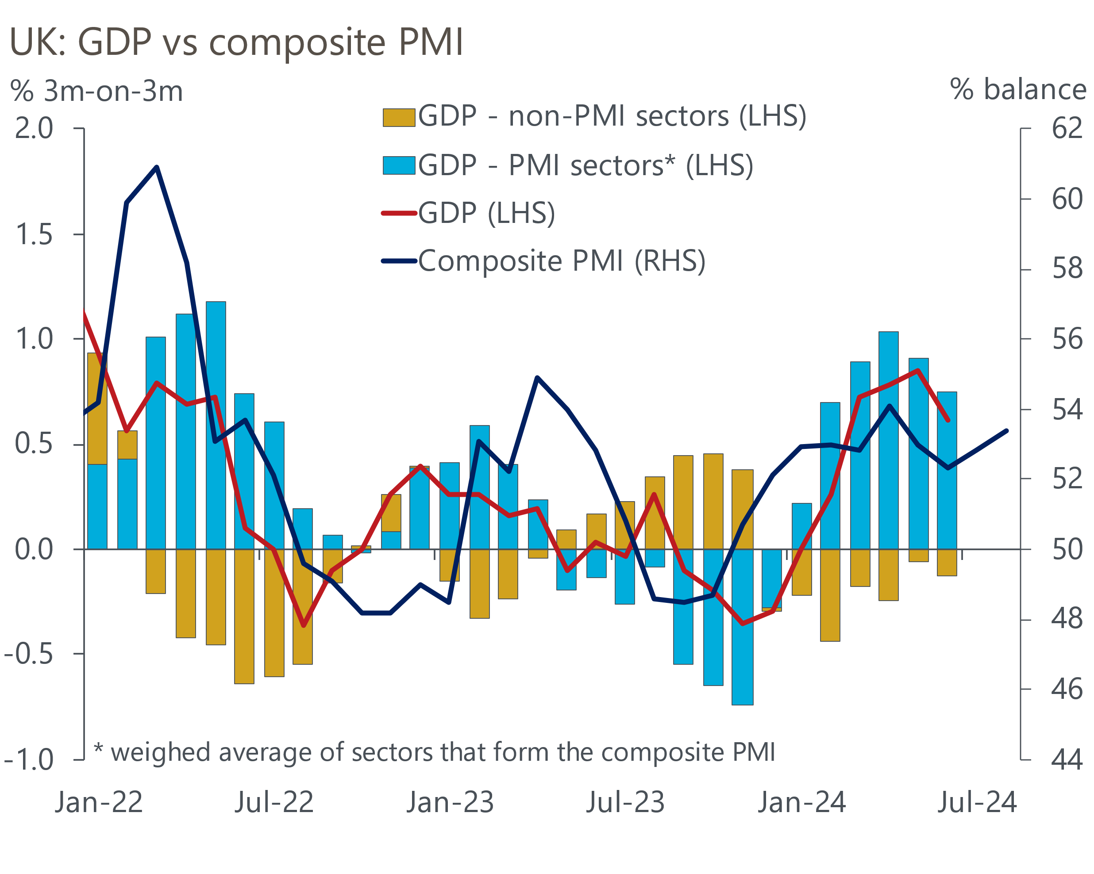
Sources: Oxford Economics, ONS, S&P Global

The S&P Global survey also reported the slowest growth in input costs for three-and-a-half years, and a further cooling in output price inflation. But once again this was at odds with the messages from the CBI's manufacturing survey, which reported a jump in selling price expectations. The week's other news on the inflation front was the confirmation that the energy price cap will rise by 10% to £1,717 on October 1. This was a slightly higher rise than we had anticipated and increases the chances that inflation will rise to 2.5% or perhaps a bit higher around the turn of the year.
On balance, we see the week's developments as leaving the monetary policy outlook little changed. The minutes of August's Monetary Policy Committee meeting were clear that the committee intends to move gradually, and we see the default path being a 25bps cut at every other meeting. To cut more aggressively, there would need to be strong evidence that inflationary pressures are softening more quickly than anticipated. In our view, recent news falls some way short of meeting that bar.
We doubt the MPC's upcoming personnel change will have much impact. Professor Alan Taylor will join the MPC on September 2 to replace Jonathan Haskel. Professor Taylor will arrive from Columbia University but he's also had a number of private sector roles. As is typically the case with new appointees, particularly those from academia, there's scant evidence of Taylor's recent views on monetary policy in the public domain. His previous academic research has warned of both the long-term risks from tight monetary policy and the impact of policy being overly loose. He was also critical of the austerity policies of the 2010-2015 coalition government. But these are no more than vague hints about his views.
Taylor's predecessor voted for rate hikes longer than anyone apart from Catherine Mann, and more recently was clear in his opposition to rate cuts. But even if Taylor proves to take a less hawkish view than Haskel, given it has been the dovish majority that have stressed the need to move slowly, the change of personnel seems unlikely to trigger a different approach to policy.
A more likely reason for the MPC to change tack would be the government opting to tighten fiscal policy more aggressively. This week's public finances data highlighted some of the challenges facing the Chancellor ahead of the Budget on October 30. Over the first four months of fiscal year 2024-2025, public sector net borrowing (excluding public sector banks) came in at £51.4bn, £4.7bn above the Office for Budget Responsibility's forecast. Higher-than-expected spending was the main culprit, and this was before the recently authorised 5%-6% public sector pay rises have had an impact (Chart 2).
Chart 2: Spending is running well above the OBR's forecast and the gap is likely to widen
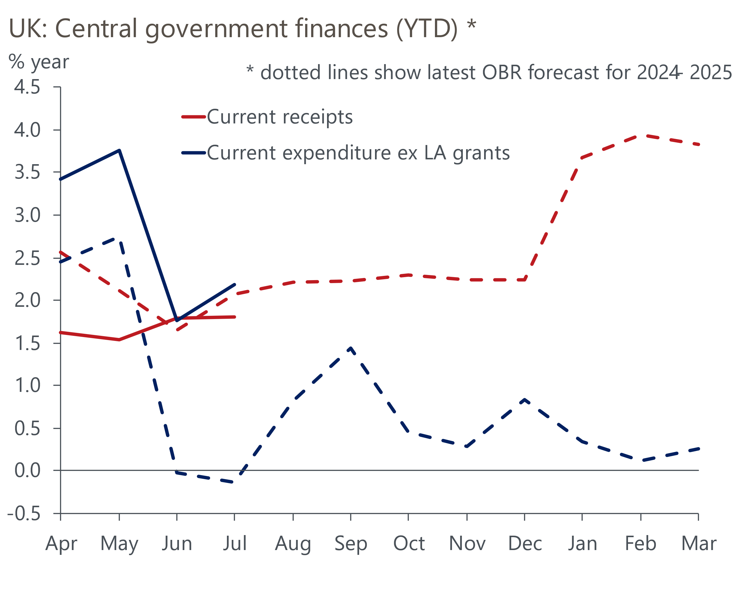
Sources: Oxford Economics, Haver Analytics & OBR
We think that borrowing could overshoot the OBR's March forecast by as much as £20bn in this fiscal year. Much of this year's extra spending will recur in subsequent years, while the Chancellor's recent review of existing spending plans focused on the current year and didn't include a range of other spending pressures the government will face in future fiscal years. So tax rises, beyond those set out in Labour's election manifesto, look certain – the only questions are how big they will be and when they will take effect.

The week ahead
Next week's only major release is the Bank of England's Money & Credit data for July. There's been a very close relationship between quoted mortgage rates and mortgage approvals over the past couple of years, with the recent fall in approvals coming on the back of an increase in the average cost of fixed rate deals. But quoted mortgage rates began to edge down in early-summer, and we think this will have been reflected in an uptick in mortgage approvals to 60,500 in July.
Net mortgage lending has been volatile of late, which has largely reflected big swings in repayments. Repayments were unusually low in June, and we expect some payback in July. However, the impact on net lending should be mitigated by stronger gross lending, in response to the pickup in mortgage approvals in the spring. On balance, we forecast a modest drop in net secured lending to £2.6bn in July.
Net unsecured lending has been similarly affected by repayments jumping around, with the volatility of retail sales an added complication. Retail sales rebounded strongly in July, after a softer June, suggesting that gross lending flows are likely to have picked up. In addition, repayments were unusually high in June, so may have fallen back in July. We expect net unsecured lending to have picked up to £1.5bn.
Table 1: Week ahead calendar
Date | Events | Period | Measure | Unit | Previous | Forecast
Aug 30 | Mortgage approvals | Jul | Level | 000s | 60.0 | 60.5
Aug 30 | Mortgage lending | Jul | Net lending | £bn | 2.7 | 2.6
Aug 30 | Consumer credit | Jul | Net lending | £bn | 1.2 | 1.5
Source: Oxford Economics

Key forecasts
Table 2: UK forecast overview
(Annual percentage changes unless specified)
 | 2022 | 2023 | 2024 | 2025 | 2026 | 2027
GDP | 4.3 | 0.1 | 1.1 | 1.8 | 1.8 | 1.7
Private consumption | 4.8 | 0.2 | 0.6 | 2.2 | 2.1 | 1.6
Fixed investment | 8.0 | 2.2 | 0.3 | 0.9 | 2.5 | 2.1
Government consumption | 2.3 | 0.5 | 2.7 | 2.8 | 1.6 | 1.5
Exports of goods and services | 9.0 | -0.5 | -0.7 | 2.4 | 2.2 | 1.7
Imports of goods and services | 14.6 | -1.5 | 0.8 | 3.1 | 2.8 | 1.9
Industrial Production | -3.5 | -0.4 | 0.0 | 0.9 | 1.5 | 1.2
Consumer prices | 9.1 | 7.3 | 2.6 | 2.5 | 2.2 | 2.2
Unemployment rate (%) | 3.9 | 4.0 | 4.3 | 4.3 | 4.1 | 3.9
Current a/c balance (% of GDP) | -3.1 | -3.3 | -3.5 | -3.3 | -3.3 | -3.3
Government balance (% of GDP) | 4.4 | 5.0 | 4.1 | 3.2 | 2.5 | 1.7
Cen. bank policy rate (%, EOP) | 3.50 | 5.25 | 4.75 | 3.75 | 2.75 | 2.00
10yr govt. bond yield (%, EOP) | 3.67 | 3.54 | 3.92 | 3.66 | 3.22 | 2.85
Exchange rate (US$ per £, EOP) | 1.20 | 1.27 | 1.28 | 1.28 | 1.30 | 1.32
Exchange rate (euro per £, EOP) | 1.13 | 1.15 | 1.18 | 1.17 | 1.17 | 1.16
Source: Oxford Economics
Table 3: Quarterly forecasts for the UK
 | 2024 |  |  |  | 2025
 | Q1 | Q2 | Q3 | Q4 | Q1 | Q2 | Q3 | Q4
GDP (% year) | 0.3 | 0.9 | 1.3 | 2.0 | 1.8 | 1.7 | 1.9 | 1.9
CPI inflation (% year) | 3.5 | 2.1 | 2.1 | 2.5 | 2.6 | 2.3 | 2.6 | 2.4
Bank Rate (%, EOP) | 5.25 | 5.25 | 5.00 | 4.75 | 4.50 | 4.25 | 4.00 | 3.75
10yr gilt yield (%, EOP) | 3.95 | 4.17 | 3.95 | 3.92 | 3.87 | 3.80 | 3.73 | 3.66
US$ per £ (EOP) | 1.26 | 1.26 | 1.27 | 1.28 | 1.28 | 1.28 | 1.28 | 1.28
Euro per £ (EOP) | 1.17 | 1.18 | 1.18 | 1.18 | 1.18 | 1.18 | 1.17 | 1.17
Source: Oxford Economics

Latest Country Economic Forecast:
August 21, 2024

Recent publications

Data Insights
Flash PMIs suggest economic growth will remain solid in Q3
Public finances continue to disappoint ahead of Budget reset
Noisy retail sales rebounded in July
Flat June completes another strong quarter for GDP
Inflation edged up in July due to energy-related base effects

Research Briefings
Rate-cut cycle kicks off but it’s unlikely to be sequential
Reeves review lays the ground for October tax rises
MPC preview – Markets hold the key to timing of rate cut
Labour's fiscal inheritance and the Reeves Review
MPC prepares the ground for an August rate cut

Contacts

Oxford Economics' UK team
- Andrew Goodwin - Chief UK Economist - agoodwin@oxfordeconomics.com
- Edward Allenby - UK Economist - eallenby@oxfordeconomics.com

